STANDARD FORMAT OF “LEHENGA DESCRIPTION”


For Online Selling Products
Design Name: SUNRISE-B
Product Colours NO.: B2
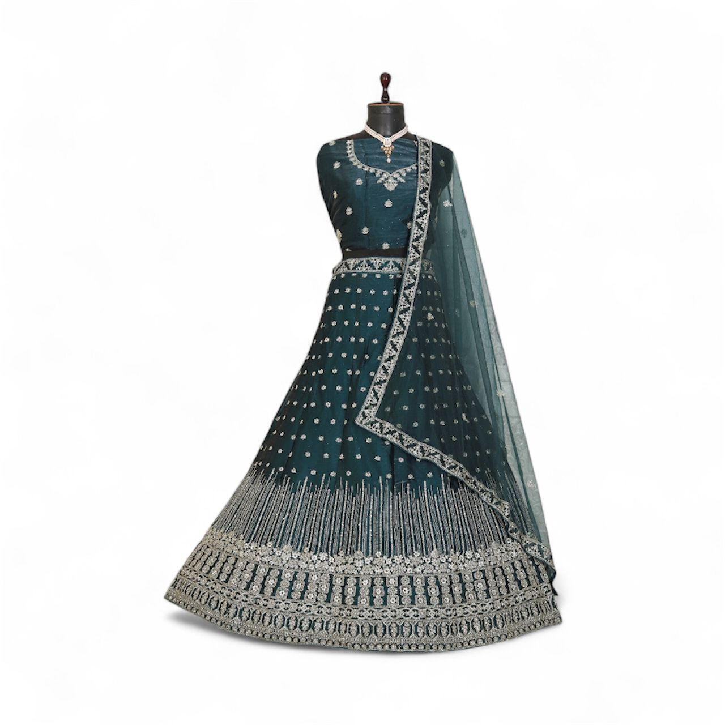
Particulars | Details
Lehenga Fabric | Burberry Silk
Blouse Fabric | Burberry Silk
Dupatta Fabric | Net Silk
Work Type | Zari & Stone Work
Colour | Green
Pattern | Girlish Designer Lehenga
Stitching Type | Semi-Stitched (Can be customized up to 44")
Occasion | Wedding, Reception, Engagement & Festive Wear
Fit Type | Regular Fit
Care Instructions | Dry Clean Only
Package Contents | 1 Lehenga, 1 Blouse Piece, 1 Dupatta

KEY HIGHLIGHTS
- Premium Burberry Silk lehenga and blouse for a rich, smooth finish
- Soft Net Silk dupatta adds elegance and comfort
- Decorated with fine Jari & Stone work for a festive, premium look
- Semi-stitched design (44” size) for easy customization
- Available in stunning colours: Wine, Grey, Blue & Gajari (as per stock’s availability)
- Ideal for festive functions, parties, and special celebrations
- Comfortable regular fit suitable for long-duration wear
- Dry-clean-only fabric to maintain shine and durability

